**DHCP (Dynamic Host Control Protocol)**

**What is DHCP?**

DHCP (Dynamic Host Configuration Protocol) is a network management protocol used to automatically assign IP addresses and other network settings (such as subnet mask, gateway, and DNS) to devices on a network.

**1.0 Network Architecture:**

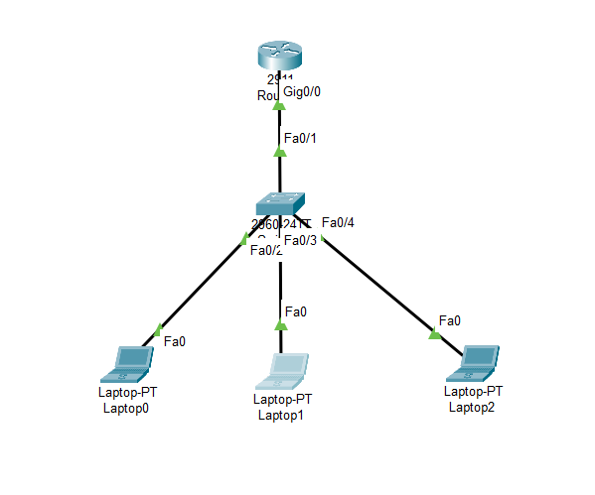

**Required Command to config DHCP:**

**Router 0:**

* enable
* config terminal
* int g0/0
* no sh
* ip add 192.168.1.1 255.255.255.0
* exit
* ip dhcp excluded-address 192.168.1.1 192.168.1.100
* ip dhcp pool CSE_STUDENT_BUBT
* network 192.168.1.0 255.255.255.0
* default-router 192.168.1.1
* dns-server 8.8.8.8

**Output:**

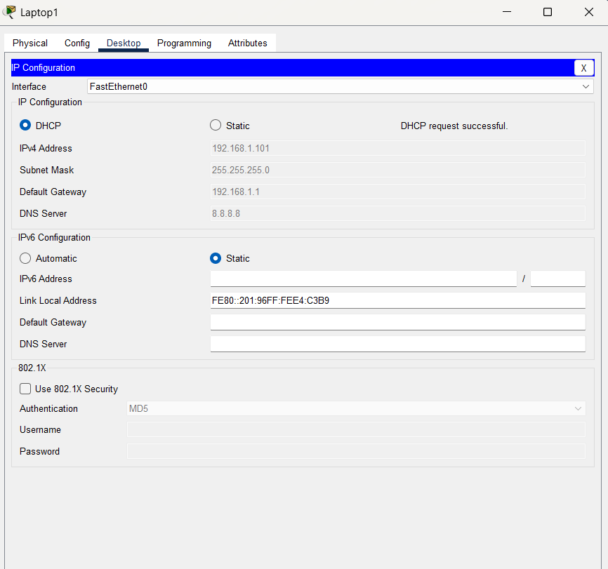

**2.0 Network Architecture:**

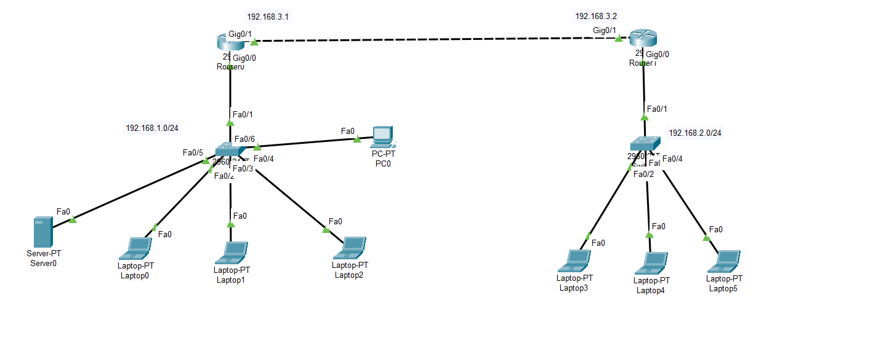

**Server-PT server0 Configuration:**

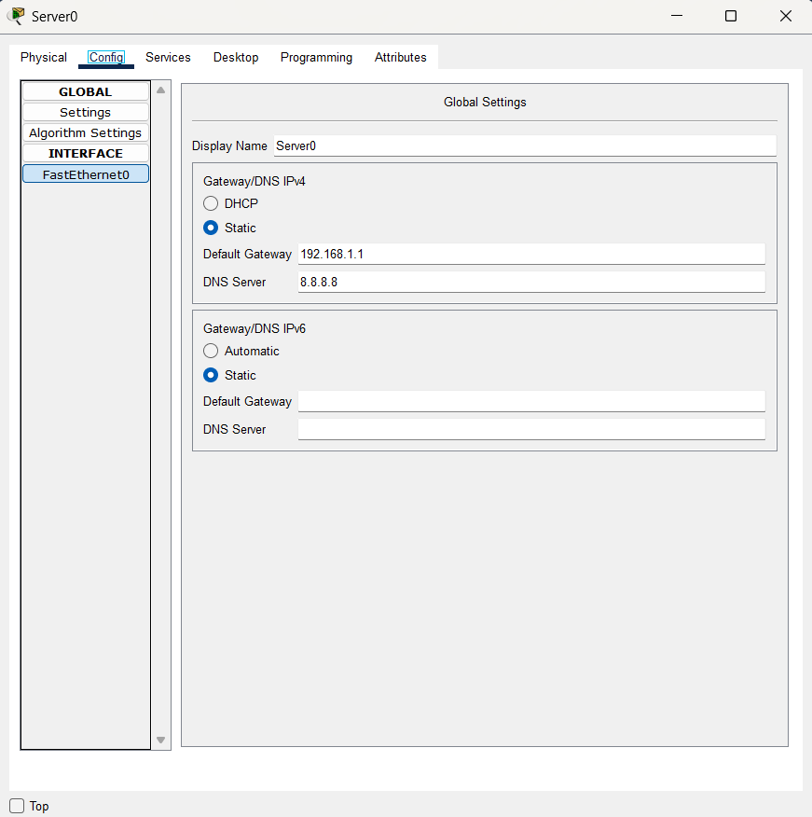

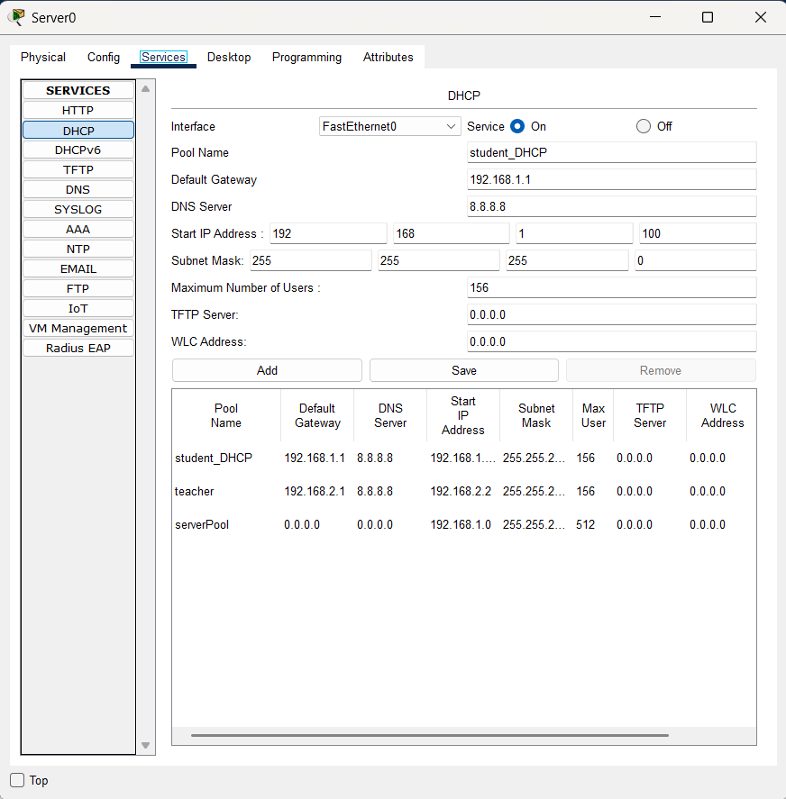

**Router1:**

* int g0/0
* ip helper-address 192.168.1.10

**Output:**

